**ActionLink**

# (Sign Language and Aciton Detection using LSTM Deep Learning Model)

**Objective:**

The aim is to create a reliable system for sign language detection using LSTM deep learning models. Leveraging the sequential processing abilities of LSTM networks, this system strives to accurately interpret and classify sign language gestures and actions. Through extensive training on diverse datasets, it seeks to achieve precise recognition of various signs, thereby improving communication accessibility for the hearing-impaired community and fostering inclusivity in a wide range of scenarios.

LSTM, or Long Short-Term Memory, constitutes a specialized architecture within recurrent neural networks, proficient in capturing long-term dependencies in sequential data. In sign language detection, LSTM models analyze sequences of hand movements, identifying patterns and making accurate predictions of specific gestures and specific Actions.

**Project Overview:**

Project includes the following steps:

1. Import and install Dependencies
2. Keypoints using MP Holistic
3. Extract Keypoint Values
4. Setup Folders for Collection
5. Collect Keypoint Values for Training and Testing
6. Preprocess Data and Create Labels anf Features
7. Build and Train LSTM Neural Network
8. Make Predictions
9. Save Weights
10. Evaluation Using Confusion Matrix and Accuracy
11. Test in Real Time

**Input:**

We collect key point values or appropriate hand gestures for each hand gesture, comprising 30 frames per input, and store them in setup folders for data collection before training the models or we can download appropriate action or sign language datasets from Kaggle or any other datasets provider

Note: each Sign or action should contains atleast 30 frames

**Output:**

The output shows appropriate message in the language you prefer for the corresponding hand gesture or action by providing data feed using opencv capture

**Sample outputs Images:**

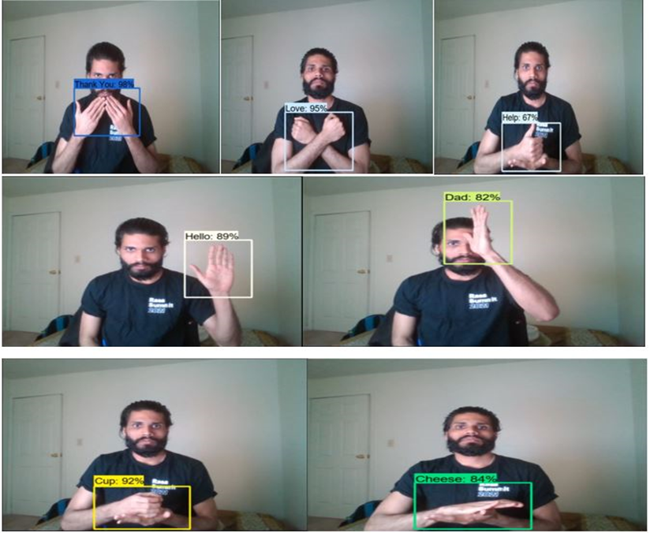

**Architecture:**

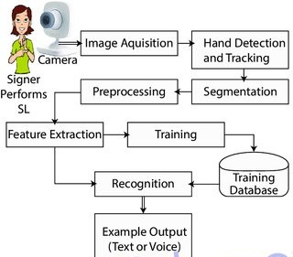

**Usecase Diagram:**

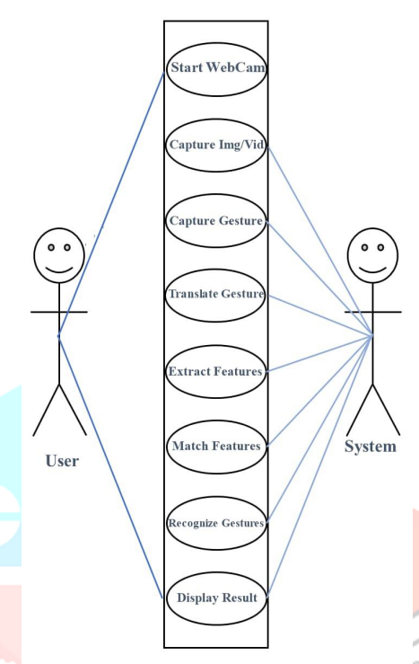

Virtual Assistants: Integrate sign language recognition into virtual assistants like Siri, Alexa, or Google Assistant to enable users to interact using sign language.

Captioning Services: Develop automatic captioning services for live events, video conferences, or online content to make them accessible to individuals who are deaf or hard of hearing.

Emergency Response: Implement sign language recognition systems in emergency response services to facilitate communication during crisis situations.

Interactive Media: Create interactive media experiences, such as augmented reality (AR) or virtual reality (VR) applications, that respond to sign language input for gaming, storytelling, or educational purposes.

Social Media Accessibility: Enhance accessibility features on social media platforms by enabling users to post sign language videos and automatically generating captions or translations.

Sign Language Translation: Build tools for translating sign language gestures into spoken language or text in real-time, enabling communication between sign language users and non-signers.

Remote Communication: Develop applications for remote communication between sign language users, allowing them to communicate effectively over video calls or messaging platforms.

Customer Service: Integrate sign language recognition into customer service platforms to offer support to deaf or hard of hearing customers through sign language interpreters or automated systems.

Education and Training: Create immersive educational experiences for learning sign language, including interactive lessons and practice sessions with real-time feedback..